Exercise 7-12: A certification program consists of a series of activities that must be accomplished in a certain order. The activities, their immediate predecessors, and estimated durations appear in the following table.
ACTIVITY IMMEDIATE TIME
PREDECESSORS (days)
A — 2
B — 5
C — 1
D B 10
E A, D 3
F C 6
G E, F 8
(a) Develop a project network for the certification program.
(b) Determine the EST, EFT, LST, LFT, and slack for each activity. Also determine the total pro- gram completion time and the critical path(s).

Exercise 7-14

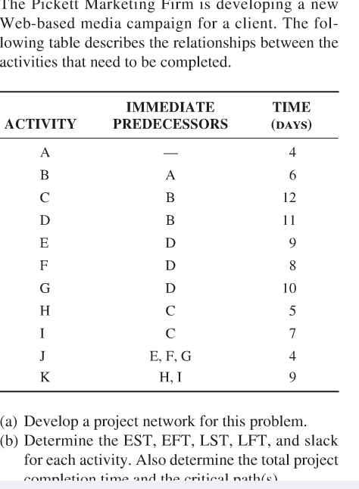
Exercise 7-16:
